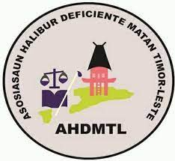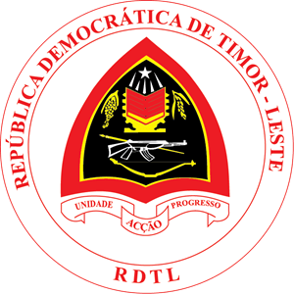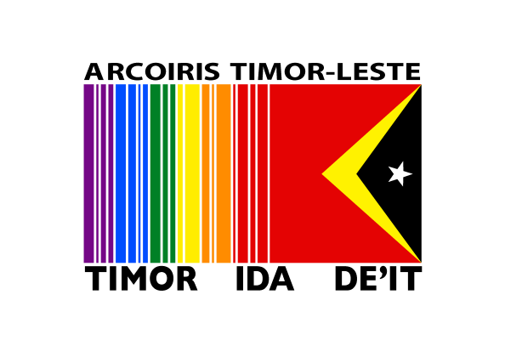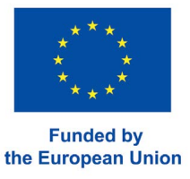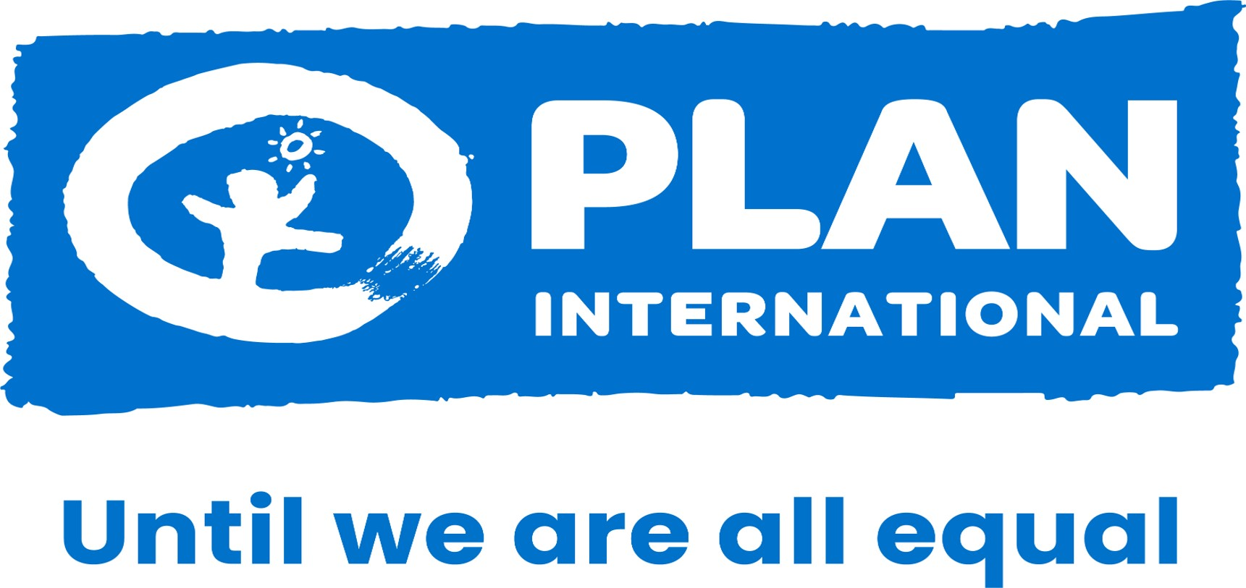

# TERMS OF REFERENCE FOR NATIONAL VIDEOGRAPHER CONSULTANT

# **EMPOWERING INCLUSION IN SUPPORTING PERSONS WITH DISABILITIES (PWDS) AND LGBTQI+ RIGHTS IN TIMOR-LESTE**

_________________________________________________________________________

# **Project Background**

Plan International Timor-Leste is implementing the project Empowering Inclusion in Supporting Persons with Disabilities (PwDs) and LGBTQI+ Rights in Timor-Leste to promote dignity, equality, and inclusion for all. Rooted in Plan’s commitment to gender equality and human rights, this initiative aims to strengthen the voices, participation, and protection of marginalized groups particularly persons with disabilities and LGBTQI+ individuals by creating inclusive environments across communities, institutions, and policy spaces.

Timor-Leste continues to face challenges related to discrimination, limited access to services, and social exclusion of vulnerable populations. Persons with disabilities and LGBTQI+ individuals often experience multiple layers of marginalization, which restrict their participation in decision-making, education, healthcare, and livelihood opportunities. The project responds to these challenges by promoting inclusive governance, capacity strengthening, community sensitization, and advocacy to ensure equitable access and respect for the rights of all.

In response, Plan Timor-Leste together with its partners AHMDTL and Acquires Timor-Leste is implementing the **“**Towards inclusive and assured futures: Unlocking the full potential of Timorese people in all their diversity. This initiative expands efforts to promote the visibility, voice, and agency of PwDs and LGBTQI+ communities, while also strengthening civil society’s capacity to advocate for inclusive policies and practices at all levels. The project focuses on strengthening community awareness, promoting inclusive policies and practices, and building the capacity of civil society actors to advocate for equality and human rights.

To support this work, the project aims to document key interventions, personal stories, and community-level impact through high-quality video content. These visual materials will serve as powerful tools for advocacy, public awareness, and engagement with stakeholders at both the national and grassroots levels.

As part of these documentation and visibility efforts, the project seeks to engage a **National Videographer Consultant**. The consultant will be responsible for capturing key moments, success stories, and testimonies from rightsholders and stakeholders. These videos will help showcase project achievements, amplify marginalized voices, and foster a deeper public understanding of inclusion and diversity in Timor-Leste.

The videographer will work closely with project staff, implementing partners, and community members to ensure the production of ethical, inclusive, and rights-based video content. All outputs must align with Plan International’s safeguarding standards and uphold the principles of dignity, informed consent, and respectful representation of all individuals featured.

This project has three (3) main expected outcomes:

|  |  |  |
| --- | --- | --- |
| **No.** | **Outcomes** | **Target Audience** |
| 1. | Families of PwD and LGBTIQ+, duty bearers, and the community at large recognize and express willingness to take action to counter discriminatory social norms, gender stereotypes, and drivers of conflict. | Families of PwDs and LGBTQI+ and local authorities. |
| 2. | PwD and LGBTQI+ have improved capacity, life skills, and critical thinking, including the understanding of gender equality, to address discrimination and access self-employment opportunities. | PwDs and LGBTQI+ including members of Champion of Change, and youngsters. |
| 3. | Current laws and policies, specifically the law against domestic violence, gender-based violence NAP, PwD convention, and cooperative and business policies are improved, supportive, and sensitive to PwD and LGBTQI+ rights. | National Authorities (MSSI, SEI, MoE, MoJ , SEFOPE) and CSOs |

# **Objective of the Consultant**

The primary objective of the National Videographer Consultant is to produce compelling and inclusive video content that documents project interventions, captures success stories, and amplifies the voices of persons with disabilities (PwDs) and LGBTQI+ individuals in Timor-Leste. The consultant will conduct interviews with key stakeholders, community members, and Civil Society Organizations (CSOs) to illustrate the impact of the project and raise awareness of the rights and challenges faced by these marginalized groups.

The final video products will be used as tools for advocacy, awareness-raising, training, and public engagement. Content will be disseminated through Plan International Timor-Leste (PITL) and co-applicants Asosiasaun Halibur Defisiénsia Matan Timor-Leste (AHDMTL) and Arcoiris Timor-Leste (ATL) via social media and other public platforms to maximize outreach and support broader efforts to promote inclusion, equality, and respect for diversity

# Scope of Work

1. **Community Engagement and Story Collection**

* Engage with target communities, including local authorities, project beneficiaries, and CSOs, to identify and document human-interest stories and community perspectives.
* Conduct interviews that reflect the lived experiences, challenges, and rights of PwDs and LGBTQI+ individuals, ensuring respectful and ethical storytelling.
* Obtain informed consent and adhere to safeguarding protocols for all featured individuals, especially those from vulnerable groups.

#### **Video Production and Development**

* Produce two professional, high-quality videos (approximately 5-7 minutes):
  + **Video 1:** Success story video showcasing individual or community-level transformations resulting from project interventions.
* Capture footage in various locations, including Dili, Ainaro, and Ermera, to reflect geographic and cultural diversity.

#### **3. Technical Support and Collaboration**

* Collaborate closely with project teams from Plan TL , AHDMTL, and ATL to conceptualize content, develop storylines, and finalize scripts.
* Provide technical guidance throughout the production process, including camera work, sound, editing, and post-production.
* Ensure that the video production aligns with Plan International’s branding and ethical communication guidelines.

#### **4. Translation and Accessibility**

* Translate scripts and spoken content into English and Tetum as required.
* Ensure accessibility of all video content by:
  + Incorporating Timor-Leste Sign Language interpretation.
  + Including accurate subtitles in relevant languages.
  + Adding voiceovers or narration where necessary.
  + Using motion graphics or visual aids to enhance clarity and engagement.

# Timeline

# The assignment duration is set at a maximum of two (2) weeks from the contract signing date. Within one week of contract signing, the videographer consultant must submit draft scripts and a production schedule for approval.

|  |  |  |  |
| --- | --- | --- | --- |
| **No.** | **Expected** | **Requirements** | **Timeline** |
| 1 | Approved video scripts | Scripts should contain a detailed description of each video story. | **3 working days** after signing a contract with PITL |
| 2 | Production plan | The production plan should include:   1. Time frame of each video stage 2. Storyboard and image | **5 working days** after signing the contract with PITL |
| 3 | Ready-made videos | Videos with source files should be in Tetum, complete with English subtitles and sign language. | Shooting should not last more than **5 working days** upon production plan approval.  Draft videos to be provided within 1 week after video shooting  Final videos are to be provided after final revision from the team |
| 4 | Promotion PITL | PITL should encompass digital solutions (e.g., YouTube ads, banner ads, etc.). Full usage rights for music (or music with granted copyright). Two fully-produced clips of approximately 2-5 minutes each in 1080p (HD). These will be shared with internal and external audiences. | **2 working days** upon signing the contract |

# Deliverables

|  |  |  |
| --- | --- | --- |
| **No.** | **Deliverables** | **Payment in Percentage (%)** |
| 1 | Provision and Approval of Storyline by PITL | 40 |
| 2 | Delivery of First Output and feedback from PITL | 30 |
| 3 | Completion and approval of final output by PITL | 30 |

# Copyright Permission Tentative Payment Schedule

All information related to this project, including audio, visual, and documentary materials is the property of Plan International Timor-Leste (PITL). The producer in the performance of the tasks under this assignment, acknowledges and agrees that all produced content shall remain the sole property of PITL, with PITL holding the exclusive rights to its usage. Disclosure of information to the public or any form of utilization thereof is strictly prohibited without prior written authorization from PITL, under PITL's Safeguarding Children and Youth and Media Policies.

# Budget

The budget allocation for video production is around **2,100 USD.**

# Qualifications and Requirements

1. **Minimum 3 Years of Experience:**

* Demonstrated leadership and experience in video production projects, with a minimum of 3 years of relevant work experience.

1. **Portfolio of Similar Productions:**

* Experience in at least 3 similar video productions, supported by work samples. Please provide links to these samples.

1. **Video Editing Expertise:**

* Proficiency in video editing with a minimum of 3 years of experience. Please include the CVs and references for each team member responsible for video editing.

1. **Understanding of Local Context:**

* Understanding and awareness of local context and issues about persons with disabilities (PwDs) and LGBTIQ+ communities.

1. **Budget Estimation Details:**

* Submission of detailed budget estimation for the proposed project.

1. **Equipment Specification:**

* Brief specification of the equipment proposed for production, including whether it will be owned or hired.

1. **License Copy:**

* Provision of a license copy from the vendor.

# Submission of Proposal

1. Interested parties must submit their proposal electronically to [**PlanTL.Jobs@plan-international.org**](mailto:PlanTL.Jobs@plan-international.org) **and CC** [**Livania.Gomes@plan-international.org**](mailto:Livania.Gomes@plan-international.org) with the title **‘’PwDs & LGBTQI+ Project: Videographer Consultant’’**. No later than **13 June 2025.**
2. Proposals should include:

* A cover letter indicating the firm's interest in the position.
* Recent Curriculum Vitae (CV) or Company profile, highlighting relevant experience and qualifications including sample of videos produced (no more than 3 pages).
* Detailed budget breakdown, including any additional costs.
* Timeframe of consultant’s work.

1. All proposals must be submitted in PDF format.
2. **Late submissions will not be considered.**

For further inquiries, please email/contact:

Email : [livania.gomes@plan-international.org](mailto:livania.gomes@plan-international.org)

Phone : (+670) - 7846- 3633